Cashdata release 2012.1.0 Patch 1 is to be applied only to Cashdata 2012.1 Release (for all licence types including Cashdata 2012 D.I.Y. Superannuation edition). This patch corrects an issue where trial balances and other non-superannuation reports error on printing for the 2013 financial year.
FILES TO DOWNLOAD
There is only one file to download.
DOWNLOAD INSTRUCTIONS
- Print this page for reference.
- Left mouse click on the 'download' icon to the left of this screen
- Select “Save this file to Disk “ (or similar) and then select an appropriate directory to store the software eg C:\Downloads
INSTALLATION INSTRUCTIONS
- All Cashdata sessions on your standalone PC, Workgroup and or Network should be closed (exited).
- If the patch is to be installed onto a Network - it is only necessary to install the patch on the computer that has the license file e.g. the server or primary workstation. This can be located by menu items File | Cashdata Setup | Startup.
- Using Windows Explorer locate the file “Cashdata2012.1patch1.exe” in your downloads folder eg. “C:\Downloads” (or other folder created in “Download Instructions” Download step 3 above) and with your mouse, double click on this self extracting file.
- Winzip self extractor will launch and display this message:
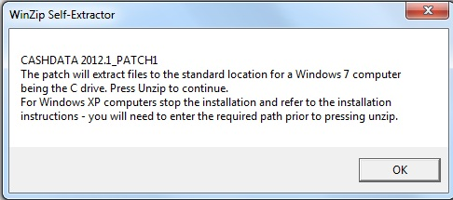

- The table below sets out the default location for each operating system. The patch is set to unzip to the path for Win 8, Win 7, Vista or Server 2008 Operation systems to drive “C”. If your operating system is XP or server 2003 you will need to change the path as indicated below.
Operating System | Standard Licence and Data Path
Win 8, Win 7, Vista, Server 2008, | C:\Users\Public\Practitioner Technologies\Cashdata\M_Detail
XP, Server 2003 | C:\Program Files\Practitioner Technologies\Cashdata\M_Detail
- After pressing “OK Winzip will display the “Unzip to folder”.
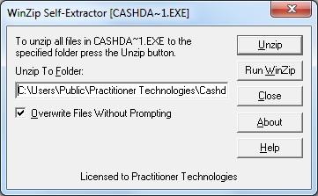
- “C:\Users\Public\Practitioner Technologies\Cashdata\M_Detail”. This is the default location of Cashdata reports for a stand alone system. If this is correct proceed by Pressing the UNZIP Button. If your operating system is XP or server 2003 you will need to change the path ( delete and retype in the Unzip to Folder] as indicated in the table in paragraph 5 above. If the drive letter is other than “C” you will also need to change the drive letter.

INSTALLATION CHECK
- Run a trial Balance for the 2013 year to check operation.

